**Ansible Playbooks**

* Simple example

* Complex example

* Playbooks are written in YAML.
* It contains a set of **Plays**
  + **Play:** Defines a set of activities (Tasks) to be run on Hosts
  + A Task can be:
    - Executing a command on a host
    - Running a script
    - Install a package
    - Shutdown/Restart
* Examples

* Example 2: List of Plays
  + Each Play has a dictionnary

* Modules

* Execution

**Demo - Run Ansible Playbooks**

* There are 2 ways

* Example 1 Steps - **ansible**
  + Create a folder called **project1** in ansible-controller machine.
  + create inventory.txt file inside **project1**:

*target1 ansible_host=172.16.0.245 ansible_ssh_pass=osboxes.org*

*target2 ansible_host=172.16.0.248 ansible_ssh_pass=osboxes.org*

* + Run command:
    - $ ansible all -m ping -i inventory.txt
* Example 2 steps – **ansible-playbook**
  + Create file *playbook-pingtest.yaml* inside **project1**

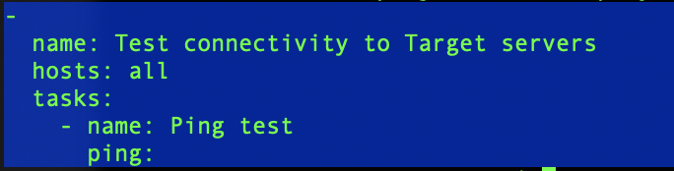

* Run command

$ansible-playbook playbook-pingtest.yaml -i inventory.txt

**Demo – Tips and Tricks**

* Download **Atom** IDE
* Create folder structure locally and a new playbook Yaml with an indentation error at line 5

* Check your YAML with <http://www.yamllint.com/>
  + OR
* Install Lint for Atom IDE. And restart.

Fix

* Move files to remote VM machine ansible-controller
* A screenshot of a cell phone

  Description automatically generatedAdd hosts param
* Run command

$ ansible-playbook playbook-pingtest.yaml -i inventory.txt

**How to Sync between you Atom IDE and your remote VM**

* Exercise 1
* Step1 - Install **remote-sync Atom plugin** andconfigure a remote sync

* Step 2 - Upload local folder to remote

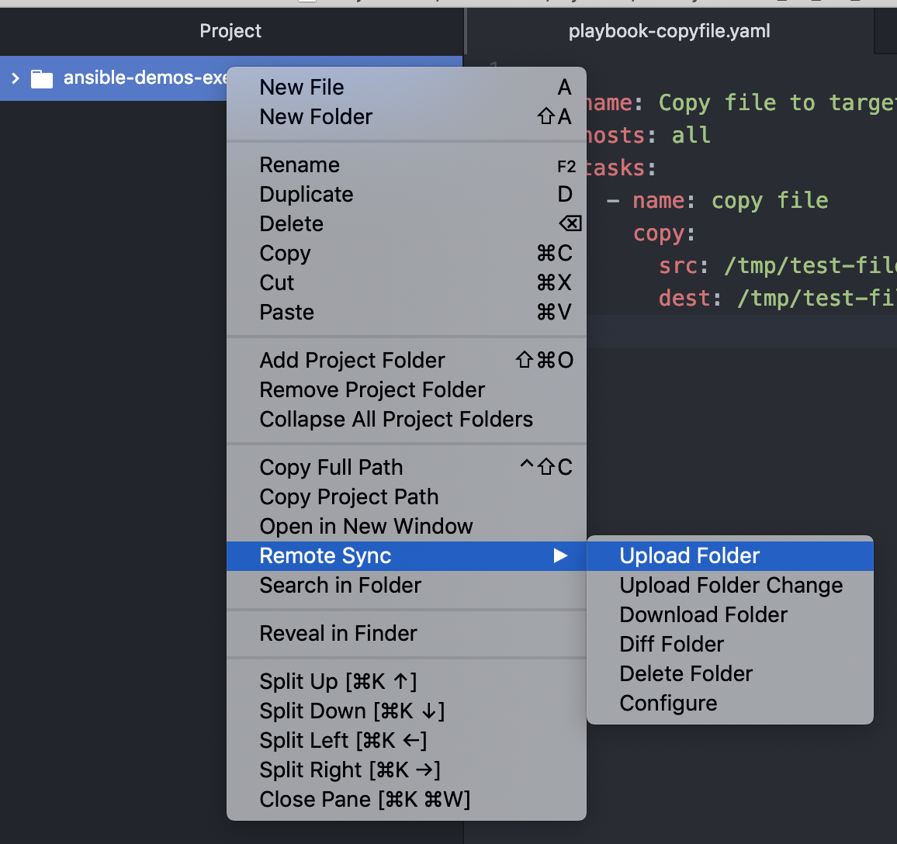

* Exercise 2 – Use **ansible copy module to copy a file from ansible-controller machine to both target servers**
  + A screenshot of a cell phone screen with text

    Description automatically generatedCreate new playbook yam and specify ***src*** and ***dest*** (remote)
  + Run command:

$ ansible-playbook playbook-copyfile.yaml -i inventory.txt

**Remark**: Principe of ***idempotency***

* If you run the copy playbook again, the parameter changed becomes ***changed=0***. It means that it did not do anything because the files were already there.

